**Joachim Meyer**

**人物生平**

**Joachim Meyer** (ca. 1537 - 1571)[[1]](https://wiktenauer.com/wiki/Joachim_Meyer#cite_note-Dupuis-1) was a 16th century [German](https://wiktenauer.com/wiki/German) [Freifechter](https://wiktenauer.com/wiki/Freifechter) and [fencing master](https://wiktenauer.com/wiki/Fencing_master). He was the last major figure in the tradition of the German grand master [Johannes Liechtenauer](https://wiktenauer.com/wiki/Johannes_Liechtenauer), and in the last years of his life he devised at least three distinct and quite extensive [fencing manuals](https://wiktenauer.com/wiki/Fencing_manual). Meyer's writings incorporate both the traditional Germanic technical syllabus and contemporary systems that he encountered in his travels, including the Italian school of side sword fencing.[[2]](https://wiktenauer.com/wiki/Joachim_Meyer#cite_note-Castle_74-2) In addition to his fencing practice, Meyer was a Burgher and a master cutler.[[3]](https://wiktenauer.com/wiki/Joachim_Meyer#cite_note-Naumann-3)

Meyer was born in Basel,[[4]](https://wiktenauer.com/wiki/Joachim_Meyer#cite_note-4) where he presumably apprenticed as a cutler. He writes in his books that he traveled widely in his youth, most likely a reference to the traditional Walz that journeyman craftsmen were required to take before being eligible for mastery and membership in a guild. Journeymen were often sent to stand watch and participate in town and city militias (a responsibility that would have been amplified for the warlike cutlers' guild), and Meyer learned a great deal about foreign fencing systems during his travels. It's been speculated by some fencing historians that he trained specifically in the Bolognese school of fencing, but this doesn't stand up to closer analysis.[[5]](https://wiktenauer.com/wiki/Joachim_Meyer#cite_note-5)

Records show that by 4 June 1560 he had settled in Strasbourg, where he married Appolonia Ruhlman (Ruelman)[[1]](https://wiktenauer.com/wiki/Joachim_Meyer#cite_note-Dupuis-1) and was granted the rank of master cutler. His interests had already moved beyond smithing, however, and in 1561, Meyer petitioned the City Council of Strasbourg for the right to hold a [Fechtschule](https://wiktenauer.com/index.php?title=Fechtschule&action=edit&redlink=1) (fencing competition). He would repeat this in 1563, 1566, 1567 and 1568;[[6]](https://wiktenauer.com/wiki/Joachim_Meyer#cite_note-Van_Slambrouck-6) the 1568 petition is the first extant record in which he identifies himself as a fencing master.

Meyer probably wrote his first manuscript ([MS A.4º.2](https://wiktenauer.com/wiki/Joachim_Meyers_Fäktbok_(MS_A.4º.2))) in either 1560 or 1568 for Otto Count von Sulms, Minzenberg, and Sonnenwaldt.[[7]](https://wiktenauer.com/wiki/Joachim_Meyer#cite_note-7) Its contents seem to be a series of lessons on training with [long sword](https://wiktenauer.com/wiki/Long_sword), [dussack](https://wiktenauer.com/wiki/Dussack), and [rapier](https://wiktenauer.com/wiki/Rapier). His second manuscript ([MS Var.82](https://wiktenauer.com/wiki/Fechtbuch_zu_Ross_und_zu_Fuss_(MS_Var.82))), written between 1563 and 1570 for Heinrich Graf von Eberst, is of a decidedly different nature. Like many fencing manuscripts from the previous century, it is an anthology of treatises by a number of prominent German masters including [Sigmund ain Ringeck](https://wiktenauer.com/wiki/Sigmund_ain_Ringeck), [pseudo-Peter von Danzig](https://wiktenauer.com/wiki/Pseudo-Peter_von_Danzig), and [Martin Syber](https://wiktenauer.com/wiki/Martin_Syber), and also includes a brief outline by Meyer himself on a system of rapier fencing based on German [Messer](https://wiktenauer.com/wiki/Messer) teachings. Finally, on 24 February 1570 Meyer completed (and soon thereafter published) an enormous multi-weapon treatise entitled [*Gründtliche Beschreibung der Kunst des Fechtens*](https://wiktenauer.com/wiki/Gründtliche_Beschreibung_der_Kunst_des_Fechtens_(Joachim_Meyer)) ("A Thorough Description of the Art of Combat"); it was dedicated to Johann Casimir, Count Palatine of the Rhine, and illustrated at the workshop of [Tobias Stimmer](https://wiktenauer.com/wiki/Tobias_Stimmer).[[8]](https://wiktenauer.com/wiki/Joachim_Meyer#cite_note-8)

Unfortunately, Meyer's writing and publication efforts incurred significant debts (about 1300 crowns), which Meyer pledged to repay by Christmas of 1571.[[1]](https://wiktenauer.com/wiki/Joachim_Meyer#cite_note-Dupuis-1) Late in 1570, Meyer accepted the position of Fechtmeister to Duke Johann Albrecht of Mecklenburg at his court in Schwerin. There Meyer hoped to sell his book for a better price than was offered locally (30 florins). Meyer sent his books ahead to Schwerin, and left from Strasbourg on 4 January 1571 after receiving his pay. He traveled the 800 miles to Schwerin in the middle of a harsh winter, arriving at the court on 10 February 1571. Two weeks later, on 24 February, Joachim Meyer died. The cause of his death is unknown, possibly disease or pneumonia.[[6]](https://wiktenauer.com/wiki/Joachim_Meyer#cite_note-Van_Slambrouck-6)

Antoni Rulman, Appolonia’s brother, became her legal guardian after Joachim’s death. On 15 May 1571, he had a letter written by the secretary of the Strasbourg city chamber and sent to the Duke of Mecklenburg stating that Antoni was now the widow Meyer’s guardian; it politely reminded the Duke who Joachim Meyer was, Meyer’s publishing efforts and considerable debt, requested that the Duke send Meyer’s personal affects and his books to Appolonia, and attempted to sell some (if not all) of the books to the Duke.[[1]](https://wiktenauer.com/wiki/Joachim_Meyer#cite_note-Dupuis-1)

Appolonia remarried in April 1572 to another cutler named Hans Kuele, bestowing upon him the status of Burgher and Meyer's substantial debts. Joachim Meyer and Hans Kuele are both mentioned in the minutes of Cutlers' Guild archives; Kuele may have made an impression if we can judge that fact by the number of times he is mentioned. It is believed that Appolonia and either her husband or her brother were involved with the second printing of his book in 1600. According to other sources, it was reprinted yet again in 1610 and in 1660.[[9]](https://wiktenauer.com/wiki/Joachim_Meyer#cite_note-9)[[10]](https://wiktenauer.com/wiki/Joachim_Meyer#cite_note-10)

**Polearms**

**The fifth and last part of this book, in which will be taught and briefly handled the fencing of the Staff, the Halberd, and the Long Spear.**

I have gathered these three weapons together in a figure, while the spear is best arranged, with its length, in the above perspective thus, as in every figure previously shown, noted with a letter, so the diligent reader should not yet leave and want thus the half staff as a foundation of all long weapons the first take for the hand and firstly advise how many the lyings thus how you the same in the work should do rightly, teach and describe.

**Of the Lyings or Guards.**

There are five principal lyings, namely the Upper Guard, straight upward before you outstretched and to both sides; the Lower Guard also to both sides; furthermore you thus also have two Near Guards and a Middle Guard; lastly the Tiller Guard.

**Upper Guard**

Arrange yourself in the Upper Guard like this: stand with the left foot forward and hold your staff with the rear part at your chest, so that the fore end stands straight up toward the sky. You should direct it to both sides in the Work, like you are now doing it straight in front of you. If you shall always stand well with the left foot forward, then you must not have your feet too far apart, so that you could always have a step forward.

**Lower Guard**

Do it like this: stand with your left foot forward and hold your staff with the rear part at your flank and with the fore end outstretched in front of you on the ground. When you hold the butt at your right flank like this it is the same, whether you hold or direct the point outstetched to left or right or straight ahead; whichever you may change to, either after his thrust, or after your techniques are performed.

**Near Guard and Middle Guard**

For these, arrange yourself like this: stand with the right foot forward and hold your staff with the middle part at your left hip, so that the shorter end and the butt point toward your opponent, but the longer end points behind you. Show your right side to him well, as you see in the lower picture in Figure A on the right hand side. The Middle Guard is the straight defence in front of the opponent, from which most fence.

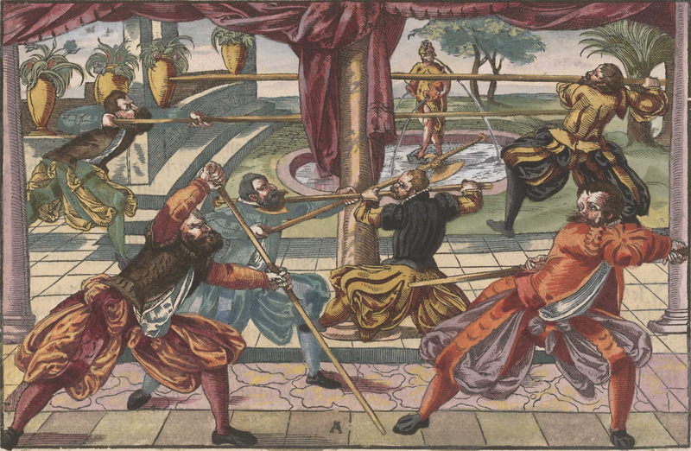

**Tiller Guard**

In this, arrange yourself like this: stand with the left foot forward and hold your staff with the fore end in front of your left foot on the ground, and the butt with outstretched arms in front of your face, all such as you can see in the second picture on the left hand side in the previous picture. You should also do the guard like this: stand with right foot forward and hold your staff behind you, also with the fore end on the ground, so you can strike deftly.

**Of the binds and the defences of the staff; also its parts.**

The staff is divided into four parts, just as was taught previously of the other weapons. There are also four binds, and the first bind is performed at the fore end or outermost part of the staff; the second in front of the hand which is foremost on the staff; the third in the middle of the staff; the fourth will be performed with the butt end through the entering. You should especially be aware and take care of these parts and binds, because different techniques are appropriate to different parts, namely, in the first part and bind, the blow and flying thrust, in the second, staying in the winding and travelling after, and furthermore in the second entering and wrestling.

There are also four principle defences with the staff, like the binds: the first with the fore end of the staff from both sides, the second in front of the hand, the third in the middle, and the fourth is performed with the butt end. The while all such in techniques is enough to understand, is without ?? difficulties ??? to handle.

**Upper Guard**

In the approach put yourself in the Upper Guard, and notice as soon as he thrusts toward your left side, then step on your right side away from his thrust, and thrust in at him at the same time he thrusts at you, then wind the long edge against his staff; so he misses with his blow, and you connect with yours.

However, if he thrusts toward your right, then step away from his thrust toward your left side, and thrust in with him again the same as before.

**The second piece from the Upper Guard**

Mark, in the approach place yourself in the Upper Guard. If he thrusts from above or below to the body, then step (when he thrusts to one side of you) away from his thrust to the other side, and strike while stepping out at the same time from above downward on his forward hand, and mark diligently, if he draws back the same, then thrust straight ahead toward his face.

**Another, how you should strike him from above down through his staff, and tear out, and strike with one hand.**

In the approach place yourself in the Upper Guard to the left, that is, so that the fore end or longer part of your staff stands up over your left shoulder, and thus step toward him with your left foot forward; if he thrusts toward your face or chest, then spring well away from his thrust toward his right side, and strike down from above with your staff (which you should be holding fast in both hands) full through on the middle of his staff, so that through this blow you come into the Right Lower Guard; from this (where he would further thrust to your face) tear with the half edge up toward your left shoulder again. While you tear upward like this, give your staff a swing with your left hand, and in this swing let go of the staff with your left hand, and strike with one hand from your right over across toward his temple. The upper blow should quickly happen together with the tear, as soon and while this blow connects, then grip your staff with your left hand again, and bring it back into the straight defence.

**Another.**

Mark, when you strike from above through his staff like this, and after you have torn up again from below, and your left hand together with the fore end of your staff has come upright again, then at once turn up your right hand together with the butt as well, and ? the same ?, lower the fore end with your left hand near your left out to the side, and turn the forward longer part of the staff again up toward his right. This must all happen in a ?. Thrust as then further with a step out straight toward his face, but be careful that you don't turn your right hand downward again to your chest in thrusting, but rather shift the same also well at your chest and inward at your left arm in thrusting ahead of you in to him. So, from the Upper Guard you have learned: firstly, how you should step out and thrust at the same time at him; secondly, striking at his staff down from above and thrusting afterward; thirdly, how you break down through against his staff from above, and tear up from below; lastly, how you should make a deceptive thrust.

**How you should thrust together with him from the Lower Guard.**

Mark, when you hold your right hand together with the butt of your staff at your right side in the approach, and you have lain your point well ahead of you out on your right side on the ground, observe as soon as he thrusts toward your face, then step step out with your right foot toward your right side, and with your left further toward his left to him; thrust in this way to his face above his left arm while he directs his thrust. You should also duck your head well down toward your right side over your staff while you thrust with him thus, away from his flying thrust, so you are the better defended.

**Another, how you should strike out his thrust, and thrust afterward.**

In the approach place yourself again in the Lower Guard as before, with your forward knee bent, so that your upper body is well sunk to your staff, and mark as soon as he thrusts, then strike his staff from your right side toward your left in a jerk out, as far as the straight defence, and before he can recover himself from his thrust, thrust with a spring out toward his face.

**Another.**

Mark, when you fallen into the Left Lower Guard in the approach, and he strikes with one hand from above toward your head, then raise both your arms, and with this spring in well under his stroke, thus parrying his blow with your staff between your hands. As soon as and while the blow lands on your staff, and is still touching, draw the butt toward you with your right hand, letting the point drop downward, direct the same between his hands under his staff to his body, and thus thrust below his staff between his hands in front of his chest. While you are thrusting in like this, turn the butt of your staff together with your right hand down again, and could drive in inside your right arm. After the thrust is performed you should be nimble with the bind again on his staff; therewith you may the better protect yourself from what he does afterward.

**How you should yield to his thrust from the Left Lower Guard, and thrust together with him.**

In the approach, step with your left foot forward, hold the butt of your staff together with your right hand at your right flank, and let the point of your staff lie outstretched in front of you on the ground, a little out to the left side, and mark as soon as your opponent thrusts at you, then step with your right foot behind your left out to the side, a little toward his right side, and as you set down your right foot in stepping behind, step quickly with your left foot also toward his right side further toward him, and thrust over his right arm (while he thrusts) to his face.

**How you should strike out his thrust from your Left Lower Guard and thrust afterward.**

Or when you stand in the said way in the Right Lower Guard, then step again as before, while he thrusts, toward his right side away from his thrust, and strike off his staff together with him from your left toward your right, and afterward thrust nimbly again as before (before he can recover) to his face.

**How you should take out from your left upward with the long edge, and thrust again through the Roses from your right side up from below to his face.**

In the approach place yourself in the Lower Guard to the left as before; if he thrusts at you, then raise both arms, and strike out his thrust upward with the point of your staff from your left toward your right with the long edge, so that your staff in the striking out ends upright, then turn your staff again near your right up from below, and thrust from the same up to his face.

**How you should jerk his staff out and thrust afterward.**

Mark, when you come in the Lower Guard to someone in the approach, and he won't work after thrusting, then let yourself with gestures mark and behold, as you want to see all first what kind of fencing pieces be, as soon as and while he extends his staff thus from him, then jerk out in an sudden jerk or blow, and thrust nimbly (while his staff lurches away from the thrust) to his face. In this striking out you should diligently take care, that you (in your excitement) don't move your staff too far to the side, but rather strike his (as taught) in a jerk out, so that your staff is straight in front of his face, and thus the thrust is performed before he can recover himself again.

**How you should fence from the Middle Guard.**

In the approach place yourself in the Middle Guard, such as is shown in the large picture printed in

Figure A on the right hand side, and take care as soon as you can reach him, throw your staff with your right hand overthwart across his face, and in the throw give your staff a strong swing with your left hand, and loose the same from the staff, so that your staff can the swifter fly across his face and around your head; while your staff is thus flying through his face and around your head, step to him with your left foot forward, and grip under your staff again with your left hand, while your staff is still flying through the air, and strike to the other from your left to your right through the face; also against his staff through where he drives before him, this blow should be performed with both hands, so that you end in the Right Lower Guard after the blow. While your staff thus in this blow falls into the Lower Guard, if he would nimbly thrust at your face (which would be left open by this movement), then step with your right foot quickly on your right side, and thrust in with him at the same time also to his face, so that you have turned the rear part of your staff together with the long edge against his, and pulled your head well away over your staff, so you are defended.



Or after you have fallen into the Right Lower Guard after this blow, and he has thrust at the opening offered, then tear out his flying staff upward with the half edge toward your left shoulder; at the same time drive your staff above around your head, and strike him outside over his left arm from your right; you should also drive this blow around with both hands; herein beware that he (while you thus drive your blow around) will thrust to the face; as soon as he does so, move the butt of your staff around lower before your face, and let the blow fly the faster. If he parries your blow with hanging staff, then mark the moment your staff lands on his or misses, then at once turn the butt end upward, and thrust above or below his staff to the body.

**Another, how you should invert before him, or give over, take out, and strike after.**

In the approach place yourself in the said manner in the Middle Guard to the left side, and step with the left foot behind your right toward him, so that in the movement you turn your back to him. While you thus turn in front of him, he will quickly thrust to your face, meaning to overtake you; then in your backward stepping lift both your hands nimbly upward together with the butt of your staff, outstretched toward his left side, so that the point hangs toward the ground, and as you turn strike his oncoming thrust with your hanging staff from your right out toward your left side, and let the same move through a full swing around your head. While it thus moves through the swing, let go with your left hand (after you have given the staff a strong swing with the same) and strike with one hand a strong swift stroke to his left ear. This is a swift piece which goes well in the first attack; if you provoke his thrust with your turn, then you take his staff out in the time of the turn, and surely hit him, if he has thrust in earnest.

The techniques learned up to now from the side lyings, I wanted to first set down, since you were to arrive in the same through striking aback, thrusting away, or fending off, so the more smoothly you know how to recover again, also the better you know how to do the techniques that follow; the same with these long weapons as with the weapons previously handled; in full fencing always from one into another, in which you need not first long consider what you are to do, but rather press on with the next technique.

Now in the straight defence as I have named it here, position yourself in the approach as shown by the pair in the previous figure.

**The first technique in the outermost bind.**

When you bind with the outermost part of your staff on the outermost part of his, then press the same in a sudden strong jerk out to the side, such that yours does not move after the pressing out, but rather thrust nimbly off from his staff ahead to his face, and that quickly before he has recovered himself from the pressing out.

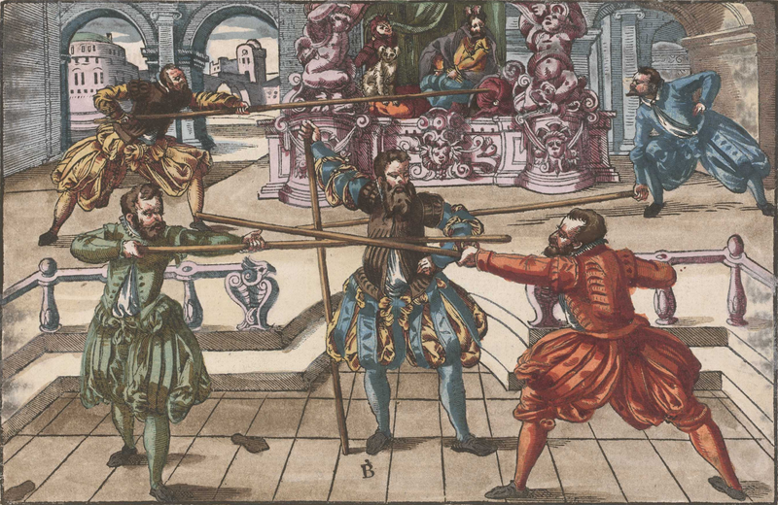

**Another, how you should move through and thrust on the other side after the jerking out.**

When you become aware in the pressing out that he is coming on nimbly with his staff, so that you cannot overtake him with the thrust you were taught, then do this: Jerk his staff again on one side as before, and let yourself seem as if you want to thrust as before, but as soon as and while he speeds his staff again toward yours, meaning to parry your thrust, then meanwhile go through under his staff, and with a spring out thrust to his face with great speed and force. This is a swift passage, when you thus unexpectedly jerk someone's staff out, and nimbly go through under, and thrust in on the other side.

**Another, how you should press out his staff and strike to his forward leg.**

In the approach bind from your left hand side, with the outermost part of your staff on the outermost of his, and press his out with a sudden jerk toward his left side, and draw your staff nimbly back again, toward your left around your head. Let go of the staff with your left hand, and strike with one hand strongly from your right overthwart, with a wide step of your right foot through his feet; grip your staff again with your left hand while the same is thus moving through in the stroke, and then strike the other with both hands through to his right shoulder, so that you end in the Right Lower Guard; from this thrust to his face after the manner described above.

Or when you thus strike through overthwart to his forward leg, then look that you grip your staff again on your left side with your left hand; as soon as you have gripped it, draw the butt back to your right at your chest, and move the left well along the staff with outstretched arm; while you draw your hands apart thus on the staff, turn the staff toward his, and strike out the same (while he thrusts), so that you strongly and forcefully come again into the straight defence with left arm stretched far out, and then thrust nimbly straight ahead to his face.

**A piece, how you should make the Brain Blow.**

Do it like this: in the approach bind the tip of your staff with the tip of his; let yourself seem as if you are earnestly looking where or how you want to thrust to his face. As soon as he notices, he will diligently take care on your leaving the bind, that he could nimbly thrust while you leave. When you place yourself earnestly, like you want to thrust, then quickly jerk the butt of your staff upward, and swing the staff back with your left hand toward your left around your head, and thus unexpectedly strike straight from above to his head, and if he would yet thrust under this, then the same does not serve, for then you are too swift with the blow to his head. This and the like pieces have the more part in the Practice, namely that you outrace your opponent with unexpected speed, when he makes the slightest mistake.

**Another, with the skewed stroke.**

Mark, when you have bound your opponent as taught above, then surreptitiously invert your right hand on your staff, and deceive him meanwhile by appearance, so that he doesn't notice what you are doing, and when he makes the slightest mistake, then step toward him quickly with the right foot, and strike a swift and powerful stroke over the hand, straight from above to his head, so that your upper body is sunk well down after the blow, then nimbly move your staff up again, and at the same time step back again with the right foot, and grab your staff with your left hand again, so that you can strongly defend yourself again. You can move to this skewed stroke as you do the aforesaid brain blow, namely when you first jerk out his staff, or else when you can hinder him with some other technique, so that you can hit him with the skewed stroke before he can come up again.

**How you should strike around from his staff and shoot over.**

Further, when you can reach the tip of his staff with the tip of yours, and he is hard on your staff, the be aware as soon as he wants to press you out to the side with force, then draw back your staff nimbly (while he is pressing out) around your head with both hands, and strike outside over his left arm to his head with a step out. As soon as this blow connects, quickly shift your staff over his near his hands, as you can see shown hereafter in Figure G; when you have thus found and barred his staff, then you may go in and thrust with the butt of your staff, or strike in front of his face with the longer part; if he moves his point up, and works it out under your staff, then follow after from below with thrusting, winding, or pressing.

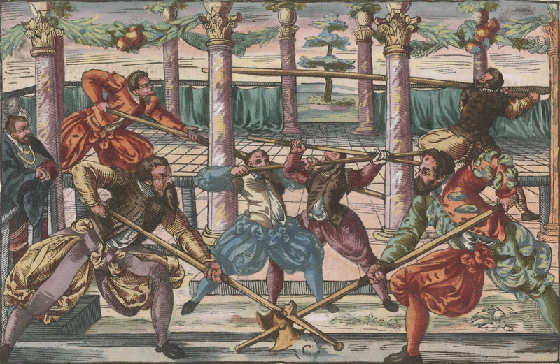

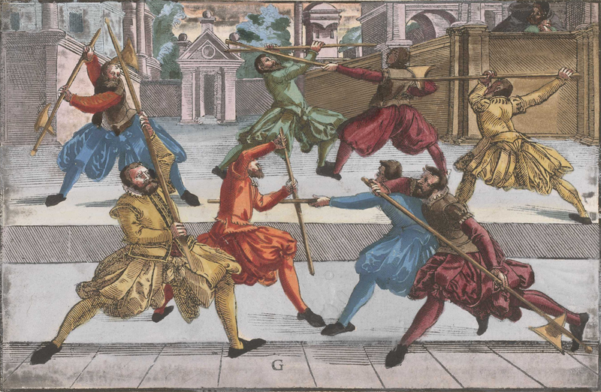

**How you should go through him.**

Mark, if your opponent is hard on your staff in the bind, and presses away from him, then go under through, and thrust on the other side. Or while he thus presses out your staff with his hard bind, again go hard on his staff (while he is still pressing) through under, and jerk him out with a ? blow from the other side, and thrust nimbly before he has recovered.

**Another.**

If someone binds hard on your staff, then hold hard against him with your bind; if he also presses against yours, then quickly go through below, and act as if you want to thrust, but don't; rather draw through below again, and thrust to the side which you were originally bound on.

**How you should learn missing in the bind.**

Mark diligently, when you have bound with someone from your left side, then diligently observe and feel just as soon as he leaves the bind, to go through below or to work otherwise, then thrust while he is thus leaving, straight ahead to his face.

**Another is a counter to the former.**

When you become aware in the bind, that your opponent is watching for your leaving, and wants to thrust to the opening while you are leaving, then let yourself seem by your appearance as if you earnestly want to move away from his staff and thrust, and when you think that he is ready to thrust, then move off his staff to the side, as if you wanted to thrust as said, but don't; rather, while he rushes in with his thrust, strike it up out to the side, and thrust in as first ?, then when he rushes in, you can easily take his staff out, and overtake him well before he can recover himself again.

Thus you should mark and be aware of what your opponent wants to fence and drive to you, so that you catch him just in his own technique, as next herefore at this one then inclined true soon after to thrust [???]. Then you must expose yourself cautiously and warily to the same, and place yourself in such a way with the appearance, as resist befalling the approximate and ignorant [???], or you have wasted your ? thrust after with reluctance, so that through this he will be all the more incited to thrust, with which thrust or blow he fails and exposes himself, as close that he so agile hardly against comes up and may recover himself [???], before then you have overtaken him. This will be expanded on further on by example in the halberd.

**A deceptive piece.**

When you have bound with someone in the approach, and neither of you will leave the other's staff, then thrust to his leading foot with a serious appearance, exposing your face, to which he will nimbly thrust, then step out to the side with your lead foot, followed by the right, and thrust under his staff from below (while the same flies in the thrust) to his face, and pull your head well away from his thrust behind your staff, so you hit him (while he is thrusting) in the face. Or when you thrust or strike to his foot, and meanwhile he thrusts to your face, then strike out his flying thrust, and at the same time spring out to the side away from his thrust, and thrust quickly and nimbly.

**How you should thrust with one hand out over his left arm to his face, wind through with the butt end of your staff, and strike to the right shoulder.**

If you have bound someone ahead from your left against his right, but he stays still and does not work, then step with your rear right foot to your right side, and go with your point hard on his staff through below, and thrust nimbly and unexpectedly from your right over his left arm to his face. In thrusting, let go of your staff with your left hand, and give the right side the thrust, so that you reach in the further. In this thrust turn up your right hand together with the butt of your staff toward your left side, and draw your staff around your head, and in this drawing around spring in nimbly on your left side. Strike thus wickedly to his right shoulder. This blow together with the thrust should be done nimbly one after another and together. Then spring back, so that you may be sure to catch and grip your staff again.

**Another, how you should wind through with the thrust.**

Do it like this: if you find yourself in the straight defence in the approach, then thrust straight from your right to his left hand, that he has placed forward on his staff; but in the beginning, let yourself seem by your appearance as if you wanted to thrust to his face. When you come near his hand with your point, go through below his staff and step with your left foot well out to his right side, and take your head well aside with you, and turn your point thus in thrusting through outside over his right arm to the face - turn your open right hand well upward, inside your left arm, so the thrust goes the deeper.

**A swift and artful thrust against one who does not work, but rather lies strongly in the defence.**

Mark, when you find your opponent in the straight defence in the approach, then place yourself thus also, and let yourself seem by your appearance, as if you wanted first wanted to see how you should fence; when he makes the slightest mistake, step quickly with your right foot out to his left side, and thrust over his left hand (which he has put forward on the staff) straight to his chest, not touching his staff with yours. In this thrust move your right hand well toward your left arm, and on the same inside, and turn your open left hand around upward, so the thrust goes the deeper, and hit surely, as you see set out in the picture on the left side in Figure E.

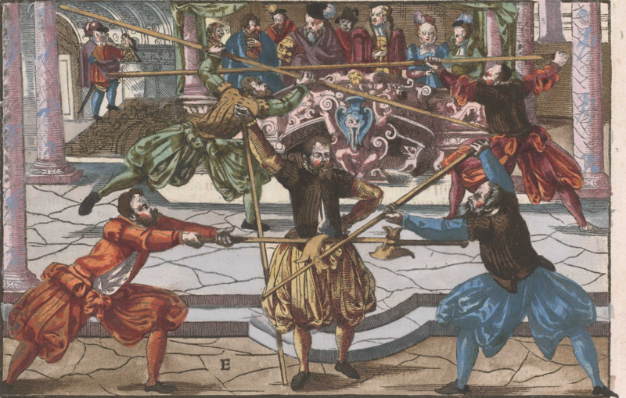

**Another: how you thrust upward through his face.**

If your opponent presses on you in the bind, then stay hard on his staff with yours; as soon as he comes so close, that the staves touch together with the beginning of the second parts, then stay below with the hard bind on his staff, and push the butt end forward with your right hand, so that your tip points toward his right shoulder, then step well out to his left side with your right foot, and thrust with your staff (still staying hard on his staff) to his right shoulder. In thrusting, turn your right hand with the butt end around toward you again, toward your chest, so that your finger is at your chest and your open hand is above. While you thus thrust, staying hard on his staff, to his right shoulder, and in thrusting turn the butt of your staff toward you again, move your thrust upward, and hit him in the face; he must direct and perform the work very nimbly and strongly.

At the same time as you make this thrust, lift your staff with both hands, and strike nimbly from above down to his face, and in this blow spring further toward his left side with your right foot.

**Another: how you should thrust a miss hard on his staff in front of him, and strike afterward long.**

In the approach don't come too near to your opponent, and mark while he doesn't want to work, then thrust to his right side hard on his staff; as soon as he notices the thrust and repels it to his right, let your staff run off near his right side, and draw it around your head with your right hand, and strike a swift stroke with one hand to his left ear.

**A good stroke in the going over.**

Do it like this: in the approach, as soon as you can reach the tip of his staff with the tip of yours, hold your point straight in front of his face, and turn yourself well on your right side, so that you turn your back to him, and while you turn your back, step with your right foot behind your left toward him, turning completely around on your right with this step, and strike with one hand, that is, around with your right hand, straight down to his head. This blow works very well when you do it right; if he thrusts at you while you are turning, he cannot reach you, because you were bound on his tip, and if he can reach you, to touch your exposed back, you surely hit him when he thrusts; the stroke runs so swiftly, that he cannot deliver any thrust before the same. You may also direct the stroke across from the middle in this turn.

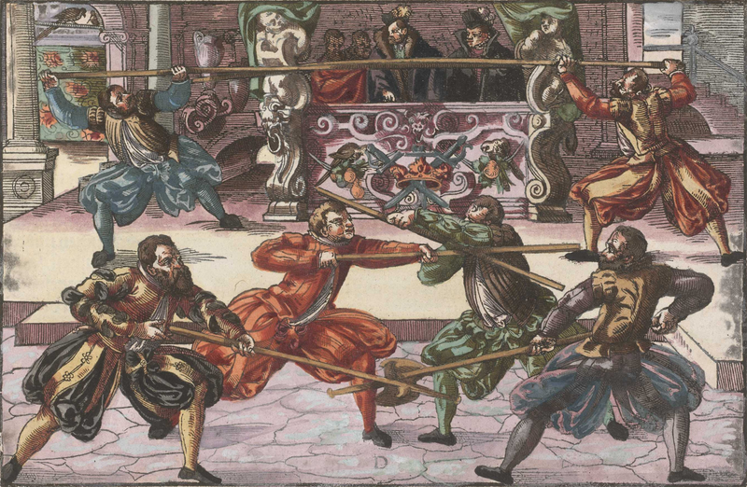

**Another, with a Middle Blow.**

When you can reach his staff with the tip of yours in the approach, then draw your staff around your head, and strike across with one hand from your right to his left ear. In this stroke step with your right foot toward his left side, and as your stroke connects, grip with your left hand hard on your staff again in front of your right, and pull your right hand and staff to your chest. While you thus pull your staff toward you, move your left hand along the staff, until your arm is lies outstretched widely on the staff, and thus the left hand (as a shield) moves on the staff in front of your face.

**The withdrawn thrust.**

When you have bound your opponent, or stand before him in the defence, and he doesn't want to work, then thrust earnestly to his face, and look under it diligently; then he is ready to parry and bear off your thrust, so don't complete it, but rather draw it back again quickly through your left hand, so that you have your left hand fully outstretched in front of your face. As you pull back your staff, place yourself with a serious appearance, as if you want to go through below, and thrust on the other side; as you thus distract with looks, you must masterfully raise your lead foot and set it down again, and as you seem to be thrusting on the other side, while he moves out to the side against your thrust to turn the same aside, thrust straight ahead at the same point, that you originally drew back from. This should be done nimbly, and performed earnestly in all circumstances.

However, when he works before you and would thrust at you, then set aside the thrust with your staff with a jerk, and move the parry nimbly into a thrust, but while your thrust is on its way, pull the same back again, as if you wanted to thrust through below again; then he will want to encounter it quickly, so while he sweeps to the other side, meaning to parry, thrust straight ahead again to where you pulled back from.

With these withdrawn thrusts you can break all guards. For example, if you find your opponent in the Left Lower Guard, then thrust straight to his face, and meanwhile observe if he starts to strike into your thrust with his staff, then suddenly draw it back toward you a little, and nimbly go through below, and thrust him on his left side (while he is moving his staff upward) over his left arm to the face; but if he moves toward your staff, go through below again, and do so until you see your opportunity to reach an opening.

**Winding.**

If your opponent binds hard on your staff from his left side against your right, and presses hard towards you in the straight defence, so that you may not depart from his staff with any technique, then stay hard with the bind in front of his hand on the staff; press with the point toward his face, so that he is compelled to move up. As soon as he has raised his staff a little, stay with your point on his continually, and wind the butt end over nimbly from your right to his left above his, press it down, and strike him on the head with the fore end (so that your left hand comes over your right), as is shown in the middle of Figure D.



**Another.**

In the approach bind strongly from your right against his left on his staff, and work with the point again toward his face, so that he is compelled to raise his staff; as soon as and while he is still raising his staff, bend down, and spring toward him under his staff with your right foot, staying throughout continually with your point on his staff, and in this spring go through under his with the butt of your staff, and turn the same over his staff on his right side, so the point comes after, with which strike him on the head, or press down with the butt of your staff (while you have wound over), and tear out with the same, and thrust with the point to his face; but if he presses upward so strongly, that you can't force his staff down with the butt of your own, then wind your point (while you must go up with the butt from the pressing) up from below to his face, near his right arm, while he presses upward. However, if he wants to lift the butt of his staff (while you wind over his staff with the butt of yours) and wind over above, then quickly turn your point from your left against his right over his right arm in around his head, and catch him around the neck with your staff, and jerk him toward you on your left side.

Or bind him from your right side against his left, and stay hard with your point on his staff, but turn the butt of your staff in from below between his hand and staff as you step in with your right foot. Tear out upward with it, as shown in the middle of Figure F printed hereafter; then work further with your point.

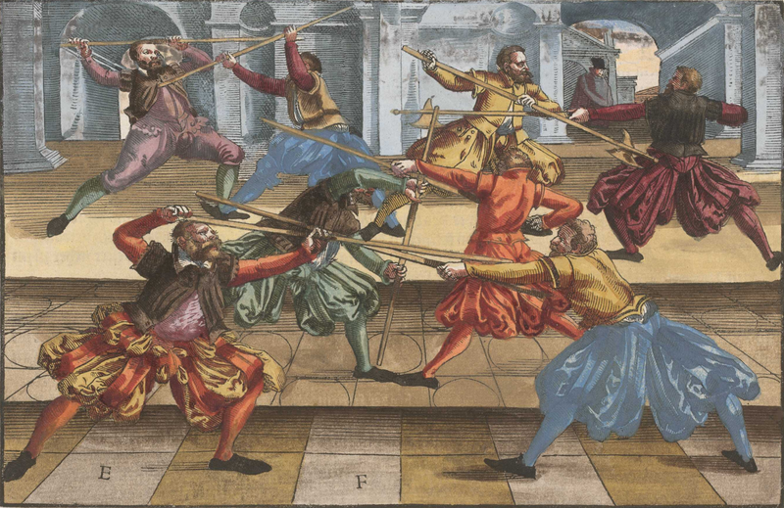

Item: bind him from your left against his right, hard on his staff in front of his hand; stay with the same point hard on his staff, and wind the butt of your staff (with a spring of your right foot) over his staff, and over his right shoulder around his neck. Step further with your right foot behind his left, and throw him over your right leg, as you can see printed in Figure C.



**A staff-taking.**

It often happens that both staves become bound together in the middle; when this happens, stay on his staff with yours, and let go with your left hand; invert it, grab both staves, and go through below with the butt of your staff. Press upward toward you with your right hand, so he must let go, or fall when you step back with your right foot.

**Driving.**

Fence like this: when you are right foot forward in the approach, with your left hand foremost on the staff, lift up your staff with both hands toward your left shoulder, and thus strike strongly through (with a further step of your left foot) against his right from above to his fingers, ending in Right Lower Guard, with bent body, then tear strongly upward through his staff, ending again in Left Upper Guard. If he thrusts meanwhile, then strike down from above, and tear out up from below. Drive this one stroke strongly into three, four, or five together, until you see your opportunity to thrust.

**A technique from the Driving.**

In the approach, as soon as you can reach your opponent, drive wickedly from above and below, as taught strongly together; when you have driven one stroke into four, then act as if you want to most earnestly and strongly strike to his right shoulder, but in striking down, move your staff nimbly hard on his staff through below, and step well out to his left side as you go through, and as you do so thrust over his left arm from the other side to his face.

In all fencing observe diligently, that you in no way let yourself be provoked or deceived, and don't thrust a lone thrust expecially the forepart in the before, but if you find your opponent in a guard that gives you an opening, then you should not commit to the same thrust, but rather see if you can provoke him with withdrawn thrusts; afterward you may change through. But if he remains too long in his guard aforesaid, then you can suddenly overtake him, when he makes the slightest mistake. But if you have bound, and may not thrust well to some opening (in the before), put in a thrust hard on his staff, and feel precisely in thrusting, whether he wants to take out or strike out your thrust. As soon as you sense this, go through below with your thrust, and help his staff fully to the side, toward which he has struck out, or thrust in on the other side while he is striking out. But if you sense that he wants to thrust at the same time as you do, then don't move your staff, but rather act subtly and secretly or unnoticed, until he makes a full thrust. As soon as he thrusts, then move out his staff in your thrust, and fully put in your upraised thrust. Thus you should not be moving in all techniques, but rather attend to how he approaches, so you can the more smoothly encounter him.

**Another from the going through.**

Drive again through his staff as before, once, twice, and when he makes the slightest mistake, then fall through below his staff, and quickly tear out his staff downward from your right toward your left, and let your staff go around your head, and strike long with one hand. But before I finish with this weapon, I will also run over and go through the others, because without it these three weapons fence from one ground.



